

**CS 255 System Design Document**

**UML Diagrams**

**UML Use Case Diagram**

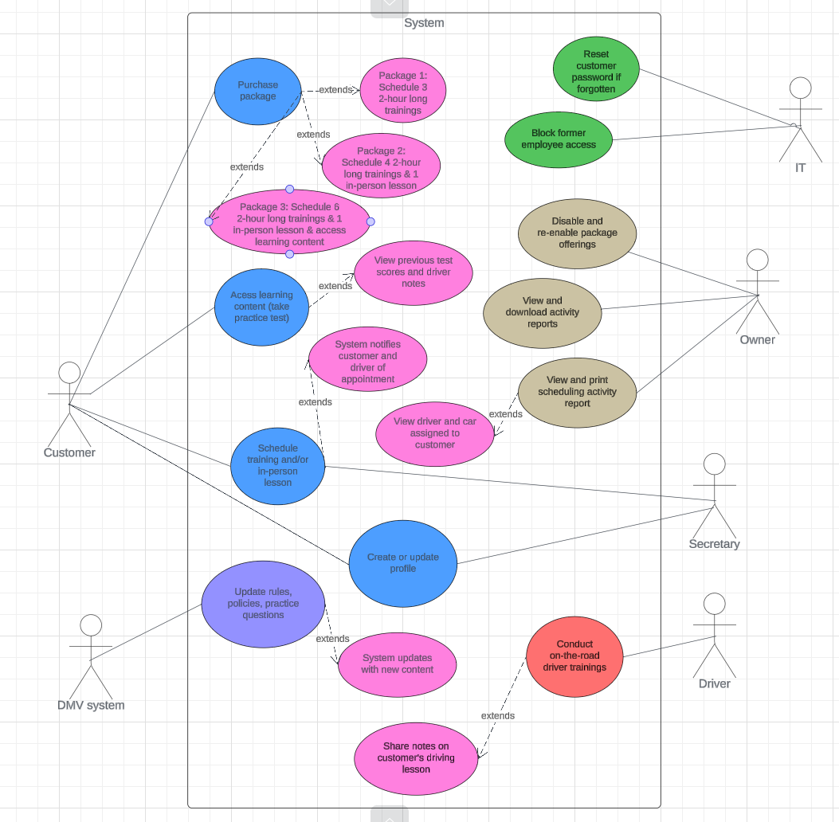

**UML Activity Diagrams**

Activity diagram 1 use case: Customer calls DriverPass to set up an account

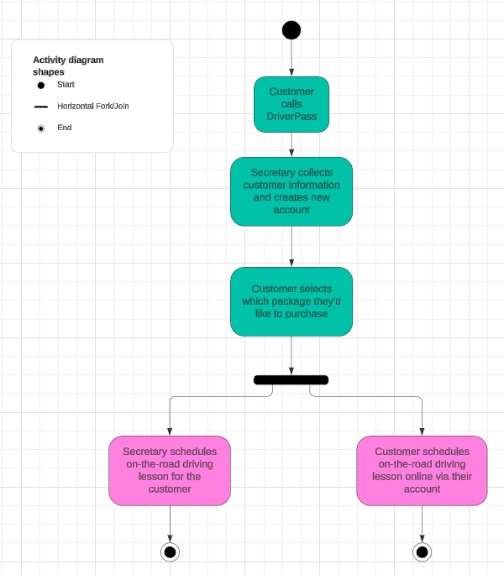

Activity diagram 2 use case: Customer completes driver’s training and views learning content

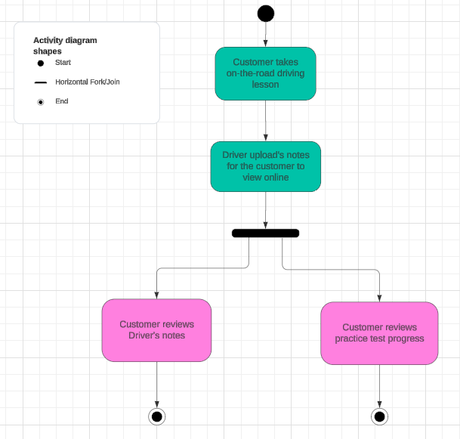

**UML Sequence Diagram**

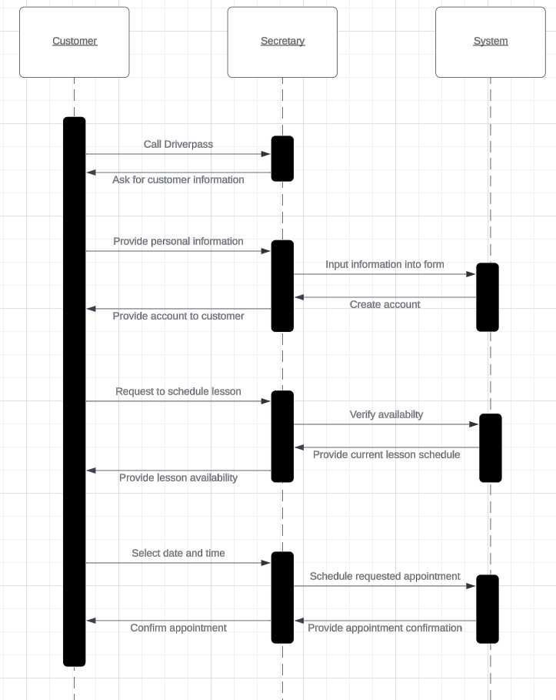

**UML Class Diagram**

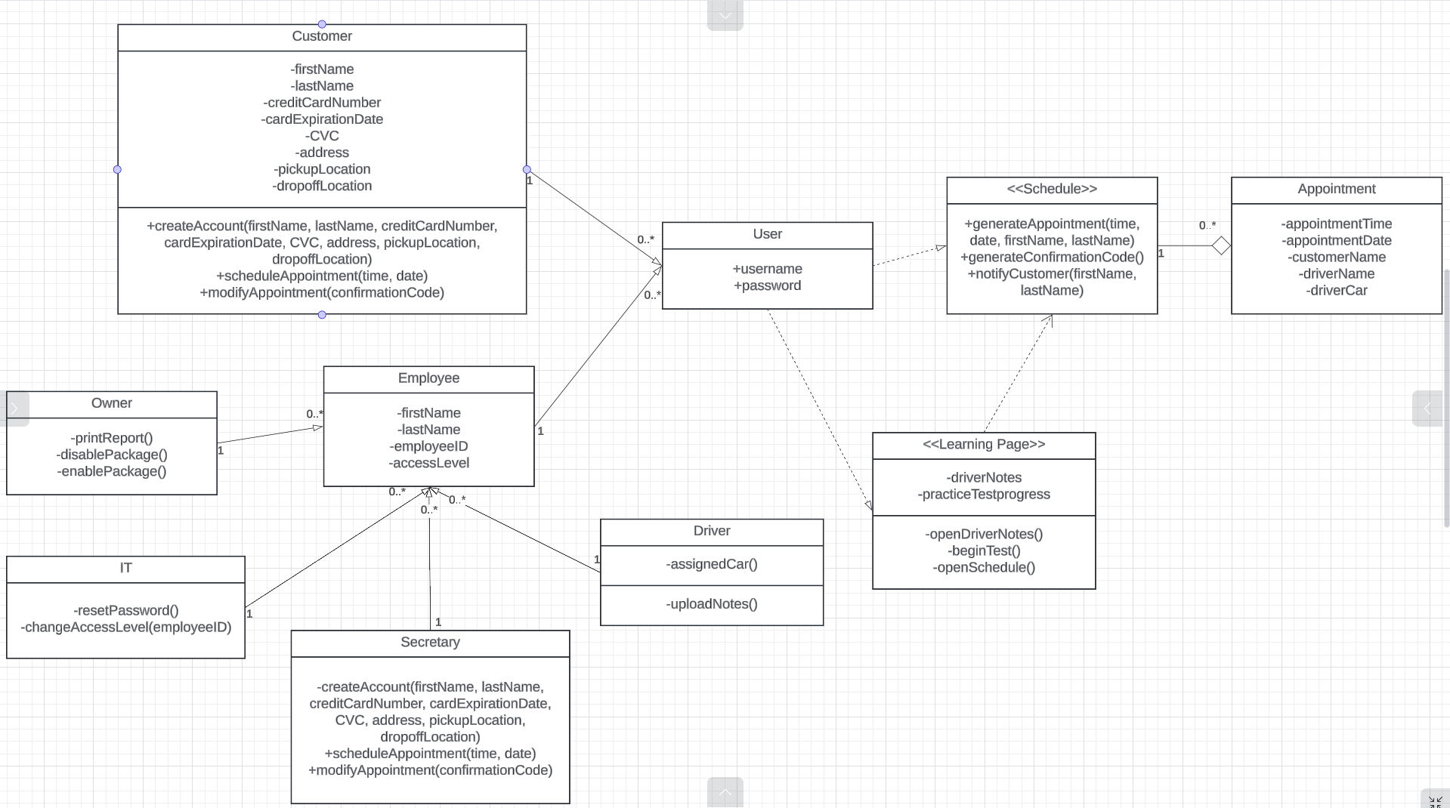

**Technical Requirements**

This system will require the user to have a desktop computer. The system will be run on a cloud platform, and the user should have a browser updated to at least the third most recent version. This means that the browser must be the most recent, second most recent, or third most recent version. The cloud platform will handle the backup and security for the system, allowing the team to focus on moderating the system.